ADITHYA R
192311369

22.Create a Simple Web Application using Java or Python and host it in any Public Cloud Service Provider (Azure/GCP/AWS) to demonstrate Platform as a Service (PaaS).
AIM: To create a simple web application using Python and host it on Microsoft Azure App Service to demonstrate Platform as a Service (PaaS).
Procedure:
- Login to Azure Portal
- Click Create a Resource
- Select Web App
- Enter:
- Resource Group: PaaS-WebApp-RG
- Name: simple-python-app
- Runtime Stack: Python 3.x
- OS: Linux
- Pricing Tier: Free (F1)
Click Review + Create → Create
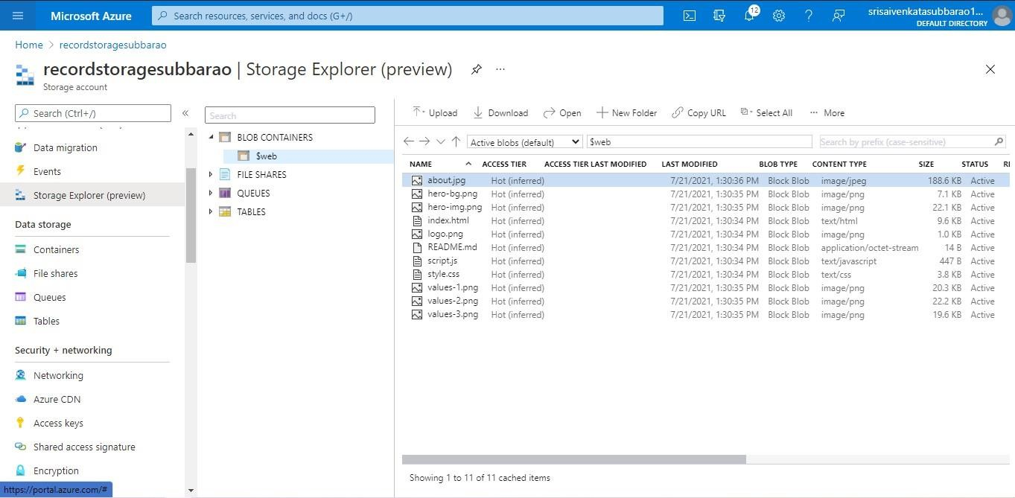

RESULT: The simple Python web application was successfully created and deployed using Microsoft Azure App Service.
Azure managed the platform (OS, runtime, scaling), while only the application code was deployed.
Thus, Platform as a Service (PaaS) was successfully demonstrated.

